CPT-202 ASSIGNMENT – 5 SQL
- USE KimTay Pet Supplies DATABASE
- Each question is worth 10 points.
- Answer each of the following questions after reading/reviewing Chapter 5 of your textbook.
- Each question requires you to write SQL Code. For each question, submit both your SQL Code and the Output/Results. See the example in Question 1.
- Submit your answers in a Word document via the Assignments link in D2L.

- For each invoice placed on November 15, 2021, list the invoice number along with the ID, first name, and last name of the customer for which the invoice was created.
select i.INVOICE_NUM, c.cust_id, c.FIRST_NAME, c.LAST_NAME
from customer as c, invoices as i
where c.CUST_ID = i.CUST_ID and i.INVOICE_DATE = '2021-11-15'
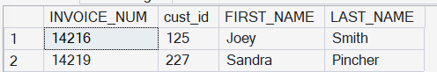
- For each invoice, list the invoice number, invoice date, item ID, quantity ordered, and quoted price for each invoice line that makes up the invoice. Order the rows by invoice number, then by item ID.
select inv.INVOICE_Num, inv.INVOICE_DATE, i.ITEM_ID, il.QUANTITY, il.QUOTED_PRICE
from INVOICES as inv, INVOICE_LINE as il, item as i
where (inv.INVOICE_NUM = il.INVOICE_NUM) and (il.ITEM_ID = i.ITEM_ID)
order by INVOICE_NUM, ITEM_ID
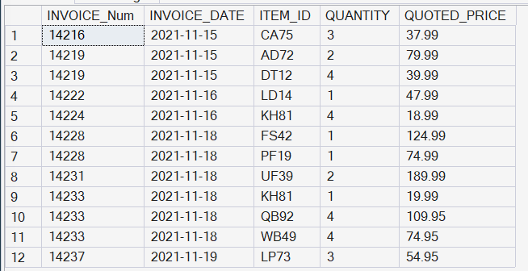
- Use the EXISTS operator to find the ID, first name, and last name of each customer for which as invoice was created on November 15, 2021.
select c.CUST_ID, c.FIRST_NAME, c.LAST_NAME
from customer c
where exists
(
select *
from invoices i
where c.CUST_ID = i.CUST_ID
and INVOICE_DATE = '2021-11-15'
)
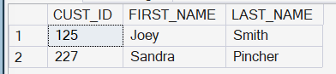

- Use a subquery to find the sales rep ID, first name, and last name of each sales rep who represents at least one customer with a credit limit of $500. List each sales rep only once in the results.
select REP_ID, FIRST_NAME, LAST_NAME
from SALES_REP
where REP_ID in
(
select REP_ID
from customer
where CREDIT_LIMIT = 500
)
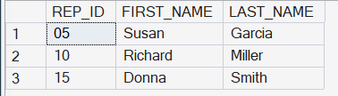
- Rewrite your query from the previous question, but this time do NOT use a subquery. Use a JOIN.
select distinct s.REP_ID, s.FIRST_NAME, s.LAST_NAME
from SALES_REP s join customer c
on s.REP_ID = c.REP_ID
where c.CREDIT_LIMIT = 500;
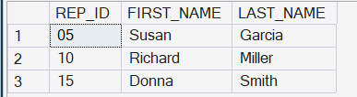
- Find the ID, first name, and last name of each customer that currently has an invoice on file for Wild Bird Food (25 lb).
select distinct c.CUST_ID, c.FIRST_NAME, c.LAST_NAME
from customer c
join invoices i on c.CUST_ID = i.CUST_ID
join INVOICE_LINE il on i.INVOICE_NUM = il.INVOICE_NUM
join item it on il.ITEM_ID = it.ITEM_ID
where it.ITEM_ID = 'kh81'
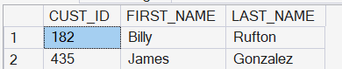
- List the invoice number and invoice date for each invoice created for the customer James Gonzalez.
select i.INVOICE_NUM, i.INVOICE_DATE
from invoices i
join customer c on i.CUST_ID = c.CUST_ID
where c.FIRST_NAME = 'James'
and c.LAST_NAME = 'Gonzalez'
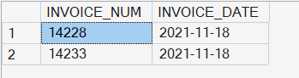
- List the invoice number and invoice date for each invoice that either was created for James Gonzalez or that contains an invoice line for Wild Bird Food (25lb).
select distinct i.INVOICE_NUM, i.INVOICE_DATE
from invoices i
join customer c on i.CUST_ID = c.CUST_ID
join INVOICE_LINE il on i.INVOICE_NUM = il.INVOICE_NUM
join item it on il.ITEM_ID = it.ITEM_ID
where c.FIRST_NAME = 'James' and c.LAST_NAME = 'Gonzalez'
or it.ITEM_ID = 'kh81'
- List the item ID, description, unit price, and category for each item that has a unit price greater than the unit price of every item in category CAT. Use either the ALL or ANY operator in your query. (Hint: Make sure you select the correct operator.)
select ITEM_ID, DESCRIPTION, PRICE, category
from ITEM
where price > all
(
select price
from item
where category = 'cat'
)
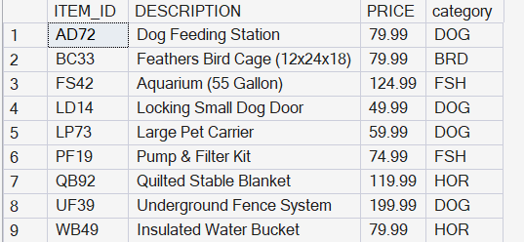
- For each item, list the item ID, description, units on hand, invoice number, and quantity ordered. All items should be included in the results. For those items that are currently not on an invoice, the invoice number and quantity ordered should be left blank. Order the results by item ID.

select
item.item_id,
item.description,
item.on_hand,
invoice_line.invoice_num,
invoice_line.quantity
from item
left join invoice_line
on item.item_id = invoice_line.item_id
order by item.item_id; 